**EVERYBOOK PORTFOLIO**

**Group members:** Tan N., Theeban K.,

Yousef Al H., Cooper C.

**For:** Mr. Smith

**Class:** ICS4U - Period A

**Due:** December, 15th, 2017

**INDEX**

1. Declaring Roles and Responsibilities ………………………………………………………………………….. 3
2. Flowcharts …………………………………………………………………………………………………………………. 4
3. Time logs ……………………………………………………………………………………………………………………. 6
4. Cost Estimations …………………………………………………..……………………………………………………. 8
5. Meeting Minute………………………………………………………………………………………………………….. 9
6. Applying Neal Whitten’s theory .……………………………………………………………………………….. 13

**DECLARING ROLES AND RESPONSIBILITIES**

At the start of the project, each member was assigned a role based on their personality type and their desire. Theeban and Tan voiced that they preferred to focus mainly on their domain of responsibility, so they were assigned the default roles of project members. Cooper was the most extroverted person in the group and so he volunteered to be the Resource Manager, where he would focus on maintaining a healthy work environment as well as keep up with his duties as a project member. Yousef was chosen by the group to be the Project Manager as he was seen as the most responsible and driven of the members, and his ability to see the big picture would allow the group to stay on task.

For the tasks that each member was to do, at the start of the project a meeting was held to assess each member’s strength and it was decided that Tan and Yousef had the highest affinity for creating the software for the program and so they would focus on programming mainly, while the other group members worked on the logistics of the project while assisting in the programming when necessary. This work environment was upheld through the duration of the project with small variations from time to time in order to keep the project running efficiently.

**FLOWCHARTS**

***1. Data collecting and entering process:***

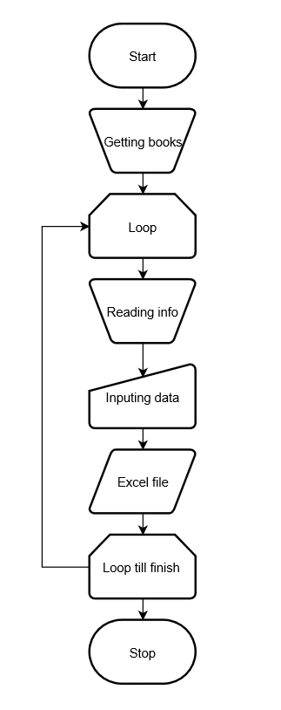

***2. Software flowchart:***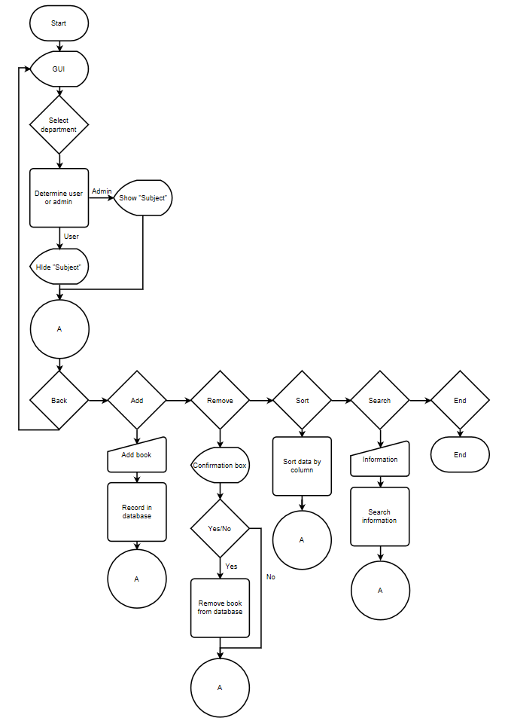

**TIME LOGS**

|  |  |  |  |  |  |
| --- | --- | --- | --- | --- | --- |
| ***Instance*** | ***Name(s)*** | ***Goal*** | ***Time*** | ***Date*** | ***What was accomplished*** |
| **Example** | **John** | **format questions** | **1hr** | **Dec 25th 2013** | **Task** |
| 1 | Cooper, Tan, Theeban, and Yousef | Make questions | 25 mins | November 20th, 2017 | Questions were made for interview |
| 2 | Cooper, Tan, Theeban and Yousef | Begin Proposal | 50 mins | November 21st, 2017 | Begin making proposal for client |
| 3 | Cooper, Tan, Theeban and Yousef | Make Portfolio | 50 mins | November 22nd, 2017 | Begin making the project portfolio |
| 4 | Cooper and Theeban | Apply chapters to project | 40 mins | November 24th, 2017 | applied chapters to project for interview |
| 5 | Tan and Yousef | Flowchart the program | 50 mins | November 24th, 2017 | Started plan for the creation of software |
| 6 | Cooper, Theeban, Tan and Yousef | Interview Client | 50 mins | November 27th, 2017 | Gathered information about the project |
| 7 | Cooper and Theeban | Flowchart book process | 50 mins | November 29th, 2017 | Created a plan for the method of collecting books |
| 8 | Yousef and Tan | Programming the project | 50 mins | November 29th, 2017 | determined how to go between forms |
| 9 | Yousef and Tan | Programming the project | 50 mins | November 30th, 2017 | Created user interface |
| 10 | Cooper and Theeban | Teacher's books | 50 mins | November 30th, 2017 | Collecting information on teachers and their spares |
| 11 | Cooper | Speaking to Teachers | 50 mins | December 1st, 2017 | Spoke to Ms. Zorec, collected book information |
| 12 | Yousef and Tan | Programming the project | 50 mins | December 5th, 2017 | Worked on method of storing/ accessing data, and worked on user interfaces |
| 13 | Cooper and Theeban | Teacher's books | 50 mins | December 5th, 2017 | Planned all department heads and who would speak to them |
| 14 | Cooper | Teacher's books | 60 mins | December 5th, 2017 | Getting book information from Department Heads |
| 15 | Cooper and Theeban | Teacher's books | 50 mins | December 7th, 2017 | Got all final information |
| 16 | Yousef and Tan | Working with data | 50 mins | December 7th, 2017 | Worked on completing the program |
| 17 | Cooper and Theeban | Flowcharting | 50 mins | December 11th, 2017 | Flowcharted |
| 18 | Tan | Programming the project | 50 mins | December 11th, 2017 | Worked on completing the program |
| 19 | Yousef | Calculating expenses | 50 mins | December 11th, 2017 | Calculated estimate for expenses |
| 20 | Cooper | Flowcharting | 50 mins | December 12th,2017 | Finalized and fixed flowchart method for getting books |
| 21 | Yousef and Tan | Programming the project | 50 mins | December 12th,2017 | Worked on completing the program |
| 22 | Theeban | Portfolio | 50 mins | December 12th,2017 | Completing portfolio chapters |
| 23 | Cooper, Theeban and Yousef | Portfolio | 50 mins | December 13th, 2017 | Working on portfolio in all aspects |
| 24 | Tan | Programming | 50 mins | December 13th, 2017 | Completing all necessary aspects of the program |
| 25 | Cooper | Portfolio | 45 mins | December 13th, 2017 | Completing portfolio chapters |
| 26 | Cooper | Portfolio | 45 mins | December 14th, 2017 | Completing Portfolio |
| 27 | Yousef | Portfolio | 50 mins | December 14th, 2017 | Completing Portfolio |
| 28 | Cooper, Theeban, Tan and Yousef | Interview Client | 20 mins | January 8th, 2018 | Presented final product and got permission to use typists |
| 29 | Tan, Yusef | Supervise typists | 1 hour | January 9th, 2018 | Supervised the typists for correct entry |
| 30 | Cooper, Theeban | Supervise typists | 1 hour | January 10th, 2018 | Supervised the typists for correct entry |
| 31 | Cooper, Theeban, Tan and Yousef | Finishing | 2 hour | January 11th, 2018 | Implemented the system with complete data, troubleshooted. Confirmed payment from Mentor College. |

**COST ESTIMATIONS**

During our data entry process we were able to calculate that it takes on average 2 minutes per different book entry. We can estimate that there are approximately 2160 different books throughout the whole high school division of mentor, but many more copies. As student minimum wages are $10.90 per hour we can divide 2160 books by 30 to see how many book entries can be completed within an hour to estimate how long the total amount of hours it would take to enter all the books. From this calculation we can estimate it will take 72 hours to enter all the book’s information into the system. The average typist wage is $12.08. Should a typist input the information it would cost approximately $869.76. In total, our team had spent 31 hours planning and creating the system as well as gathering all the books in the entire school. An average salary for a job to this scale would be $18 per hour. We can calculate the expense of our team to be approximately $558. Due to these calculations of salaries we can expect the general expense of our program to be implemented into the mentor college high school division database to be approximately $1427.76.

**MEETING MINUTES**

***Meeting 1:***

Date: November 27th, 2017

Start time: 9:09    End time: 9:21

**Topics:**

1. Timeline

* It was determined the product must be completed before June to avoid serious issues with inventory.
* In order to make sure the project would be completed on time, a follow up meeting would be scheduled in two weeks.

2. End Product

* The details of the end product were given, and the team was told the product needed to include the Title, Author, Publication Date, Number of Copies, Subsections, Owner’s name, Location, ISBN number, Condition, and Edition of each book.
* The product should also be able to update the system without deleting the changes that other users make.
* It was also determined that if the group had time the product could also include online vendors that sell the book and the cost of replacement.
* The product should also be able to retrieve information in specific ways such as alphabetical order and subject.

1. Intended Use

* The client requested that above all else the product must be user friendly for non-tech focused individuals, as it was intended for teachers of different backgrounds in experience with technology.

1. Cost

* Now that the project members were given an idea of the product, the client expects an estimation of the cost in a follow up meeting, two weeks from the first.

***Meeting 2:***

Date: December 7th, 2017

Start time: 8:54    End time: 9:13

**Topics:**

1. Costs

* The difference in price and time range between hiring a typist or hiring students to input all of the data. It was decided that typists would be hired, as the cost was not much greater, and the time that would be saved was worth the cost, and dependency of a hired professional.
* The cost of the actual software was given and with this combined with the cost of inputting the data, a final cost was decided on.

2.  The Software

* A demo of the prototype was given, and any concerns with the designs were noted.
* All requirements were met for what was expected of the product.

3. Follow up

* The client gave a list the aspects of the product that were to be finalized for the next meeting on the 8th of January, at this point the requests are mostly visual.
* In the follow up, the client also expects a plan on the company that will provide the typists for and a final cost of the product.

***Meeting 3:***

Date: January 8th, 2018

Start time: 9:10    End time: 9:30

**Topics:**

1. The Software

* All changes that the client requested to the software have been made and it is now finalized.

     2.    The Typists

* A final cost for the inputting of the data is provided.
* A list of what rooms the typists will be working in and what subjects.

  3.     Implementation

* The client requests that the system be implemented between the meeting and the next meeting on the 12th of January

***Meeting 4:***

Date: January 8th, 2018

Start time: 9:00    End time: 9:20

**Topics:**

1. Troubleshooting

* The client inquired about any troubles in implementing the system, but it had all gone smoothly

2. Payment

* The client and the team shake hands on the deal, and the client wires the payment to TTYC company.

**APPLICATION OF NEAL WHITTEN’S ADVICES**

***14 - Project Manager***

The project manager constantly updated the top three problems, this allowed the resource manager to easily assign tasks to each member of the project and increased the focus and drive of the team. Our outline for how the project should look and how it should be done was created by the entire team, however it was decided by Yousef whether or not the proposed plan was the one to be followed. When problems arise in the project Yousef went headfirst to solve them and did not worry about the easiest action, he followed through with the best possible action. As the project progressed Yousef made sure that the project was being driven to its timely end, because he is solely responsible for the success of a project.

***15- Resource Manager***

At the beginning of the day, Cooper monitored the progress of each member of the project to assess their work ethic and contribution to the whole. Group members are assigned tasks everyday and expected to follow those tasks through to completion; a conversation is had with any individual who did not complete their roles as expected. When frustration and doubt began to arise in the project, the resource manager encouraged the group members to continue with their work and to believe in the vision. When group members were being a helping force to the project, these members were given validation and appreciation for their actions. Work environment was maintained with a gentle but strong force.

***16- Project Sponsor***

The project sponsor coordinated our meeting with the client. This project was unable to be completed without the choice of the project sponsor. The project sponsor was looked to assist in scheduling meetings with the client. Gave funding in the terms of class time. In issues that involved deep problem solving skills, the project sponsor aided decision making processes. The project sponsor also worked to keep project members on task as they were becoming distracted due to unproductive activities. The project sponsor remained friendly at all times, was easily approachable and gave recognition to those doing good work.

***29. The effect of multitasking on productivity***

During the project, there can be imbalances of work that flow from person to person depending on their productivity potential for a particular time. Yousef took upon both the work of flowcharting and coding the project while the other members were working on less important tasks. When working on both of these tasks the productivity of the team went down very quickly because the human brain cannot truly multitask; it is only able to switch focus between the two tasks which is highly ineffective. Tan took upon this task of flowcharting while Cooper and Theeban continued to work on the gathering books information allowing all aspects of the project to be completed at the highest potential quality.

***24. Contingency buffer***

In preparation for the estimated time of completion for the program, the aim was to have the program completed a week before it was due. It was nearly completed, allowing for a week to be spent on resolving issues, making the product the highest quality possible, and creating a portfolio documenting the entire project. Any Roadblocks that came up were solved with our contingency week. These problems occurred when the optimal plan of action was unclear. To find the book information of teachers took longer than expected because we had to gather information about how the school works; involving the department heads of the school and requesting permission from Mr. Hall. The contingency buffer that was set up at the start of the project ensured that the project would be completed on time and without any unresolved errors.

***25. Scope Creep***

Our project increased in scope as the project continued on, partly as members of the group were looking to find a different task to work on that provided more fulfillment compared to menial tasks that had to be completed for the success of the project. These tasks were quickly shut down. When Cooper created the initial logo it was on the edge of the scope of the project because a logo is an additional aspect of the project, this gave helpful knowledge about how to create an effective logo to the team; this time could have been used much more effectively to work on completely necessary aspects of the project, and Yousef made sure that Cooper did not spend more than half of a period on this aspect of the project. As well, during the programming of the software, many extra features were considered, but in order to meet the deadly and have a morgle lean and efficient program, these features were cut.

***26. Project tracking meeting***

On Wednesday November 29th, 2017 we held a project tracking meeting. Both the coding team and the data team had brought the progress of what they had done and how much they had completed. Yousef helped us set our goals for the next project tracking meeting and helped establish major milestones of where we should be. At the end of the project tracking meeting, yousef went through the agenda of what had been accomplished in the meeting as a quick overview and reminder of what had been accomplished. He also allowed us to assess what had happened in the meeting. At the very end of the agenda he provided us with our goals of what we should have accomplished by the next tracking meeting and motivational words to encourage us to work hard to complete those goals.

***27. The day after***

Neal Whitten recommends to put aside one day a week to check on the progress of the project. Due to the time frame of the project, a whole day was unrealistic, but there were small meetings each week to check on the progress of each of the tasks at hand. The coding team was behind the schedule on making the user interface. At the project tracking meeting this problem had come to Yousef’s attention and due to this setback, he decided to schedule an escalation meeting to help alleviate the problem. Yousef decided to take this issue to Mr. Smith, as it was believed that he would be able to help,  and with his guidance,  to this project escalation meeting in order to bring this problem to his attention as well. At the project escalation meeting, they decided to allocate more group members to the user interface. Due to allocating more members, the group was able to finish the task on time.

***28. Manage to your top 3 priorities***

Yousef told each group member the top three problems at the beginning of each workday and tasks were created based on the problems and strengths of each member as determined by Cooper. The top three problems often changed as problems were solved, this required constant re-evaluation. Managing to the top three problems helped us to manage scope creep, and kept the group focused and hardworking.

**29. Treating project members equally**

All project members were given equal responsibility to complete necessary tasks that they have been assigned. Hard work is rewarded and laziness is immediately stopped regardless of the member in question. Cooper spoke regularly with each of the project members to ensure they understood their roles, were on their way to complete their tasks, and were happy with the work they were doing. When there was a quarrel between two project members, Cooper called for a meeting where respect in the workplace was brought up and the issue was resolved. As a result of the work Cooper omletTE, a respectful work environment was promoted and business ran smoothly.

***30. Inspect what you expect***

In the completion of the project, occasionally project members would find themselves seemingly without anything to do. In this case they would often do nothing and refrain from bringing this to the attention of Yousef. When he noticed this, he would keep an eye on that project member and when he saw that they had nothing to do, he would assign them to a new task. Yousef was careful not to micromanage the actual work that the project member was doing and give them freedom over their own work while still keeping the project moving efficiently.

***31. Escalate is not a dirty word***

Throughout the duration of the project, there were problems such as what the format of the project was going to be based on. These problems were brought to Yousef’s attention who then brought the problem to the project sponsor. Problems discovered by all group members were first reported to Yousef who escalated the problem unless it was felt that ***additional*** knowledge past the scope of the project was necessary; in this case the project sponsor was informed of the problem. This quickly brought problems to their timely end. For example during the initial portion of the project the project sponsor was spoken to, to ensure the format that the program will be based on is acceptable.

***32. Project risk value***

When problems occured in the project, we often escalate the problem to the project sponsor, we never increased our project risk value to the point of needing escalation to the client. Problems were quickly solved following the escalation due to quick thinking and collaborating ideas from across the team. We worked to decrease our risk value by looking ahead and solving problems immediately as they arose. Problems that we began to try to solve were worked to closure and given intense attention and problem solving.

***33. Run an effective meeting.***

We planned meetings a week in advance to ensure that all members could attend the meetings. At each meeting we established a meeting leader, a note taker and someone to count the meeting minutes. Scope creep is managed during our meetings by moving back to the topics that we had planned to cover. Meeting ground rules were established with all members before meetings were hosted.

***34. The S-curve 50/70 rule***

We worked to gather all book information and do the necessary aspects of programming halfway through the project to ensure that we had time to create a product that was visually appealing and fully functional. Frequently progress was assessed to monitor how much time we had left and our expected completion time to manage the workload on project members. After the project was functional the remaining time could be spent to fix any problems and make sure that the product was at the best it could possibly be.